**Class Diagram:**

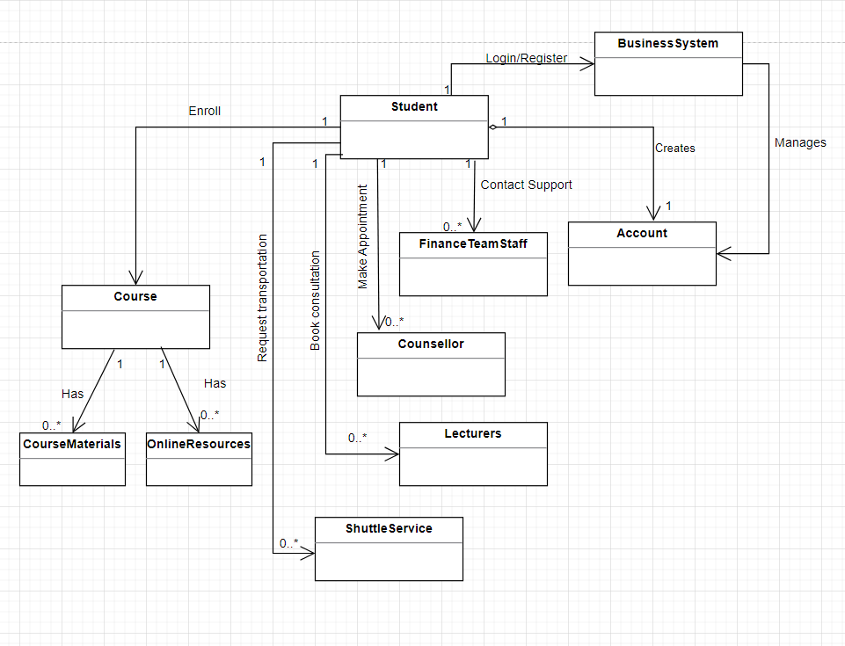

| Class: Student | Represents students of the college |
| --- | --- |
| Responsibilities: | * Manages personal information in their account * Provides method to access course materials and online resources, view semester calendar, reach out to online support, receive upcoming event(s) information, navigate through virtual tour, receive campus news and announcements,enrol into classes, refer to exam timetable and reach out to student support resources |

| **Class: BusinessSystem** | Represents the business system used by the college |
| --- | --- |
| **Responsibilities:** | * Maintains student database,course materials and online resources * Allow students to enrol online, add course materials and online resources |

| **Class: FinanceTeamStaff** | Represents the college’s Finance Department |
| --- | --- |
| **Responsibilities:** | * Manages student accounts and student payments * Provide methods to support students experiencing issues with their account/payment |

| **Class: Counsellor** | Represents counsellors of the college |
| --- | --- |
| **Responsibilities:** | * Provide methods for students to reach out to student support resources to make appointments |

| **Class: Lecturers** | Represents lecturers of the college |
| --- | --- |
| **Responsibilities:** | * Provide methods for students to reach out to student support resources to book consultations |

| **Class: ShuttleService** | Represents shuttle services provided by the college |
| --- | --- |
| **Responsibilities:** | * Provide methods for students to reach out to student support resources to request for transportation |

| **Class: Course** | Represents course archives of the college |
| --- | --- |
| **Responsibilities:** | * Provide methods for students to access course materials and online resources like reference books and academic journals |
| **Subclass: CourseMaterials** | Represents course materials stored by the college |
| **Responsibilities:** | * Provides methods for students to access course materials like past-year papers and course exercises |
| **Subclass: OnlineResources** | Represents online resources stored by the college |
| **Responsibilities:** | * Provides methods for students to access reference books and academic journals |

**Structural design pattern:**

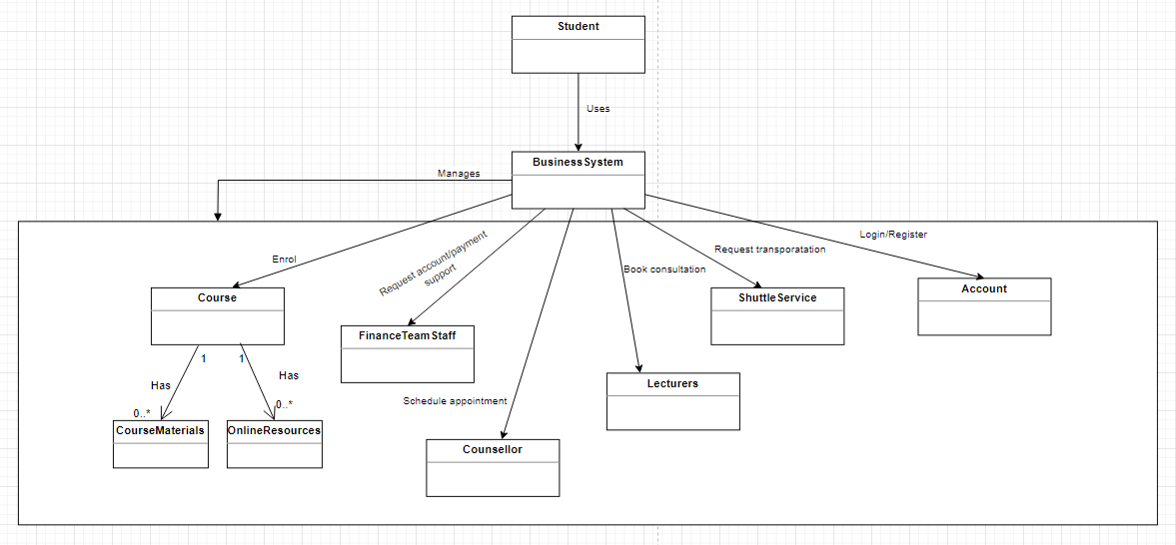

The structural design pattern is mostly responsible for assembling objects and classes into a much more complex structure but still ensuring that the structures are efficient and adaptable. The facade pattern was specifically selected as it offers a simplified interface to the business system used by the college; by hiding the complexity of the underlying system, the client code will be easier to interact with. Assuming that the facade class acts as the entry point to subsystems, allowing clients to interact with any underlying subsystems without needing any knowledge regarding internal functionalities.